Look at this crazy picture.

*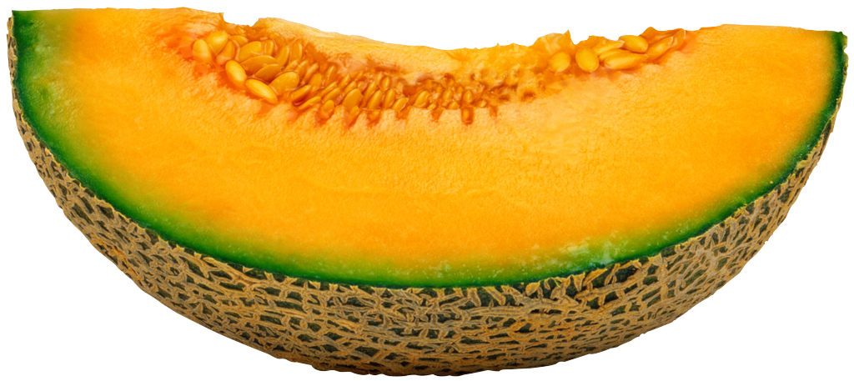*

*married in vegas cuz they cantaloupe LOLLLLLLZZZZZZ*